
PROGRADE DIGITAL™ ANNOUNCES TWO NEW HIGH-SPEED, USB 4.0
CFEXPRESS™ & SDXC™ UHS-II DUAL-SLOT READERS
Simultaneous Data Transfer from Both Slots with Up To 40Gbps Speeds, Enabling CFexpress and SDXC UHS-II Memory Card Users to Double the Performance of Data Transfers
San Jose, CA April 17, 2026, 8:00 AM PT —ProGrade Digital™, founded with a mission to provide the highest quality professional grade digital memory cards, workflow solutions, and solid-state drives, announces two new dual-slot card readers: the CFexpress™ Type B / SDXC™ UHS-II Dual-Slot USB 4.0 Card Reader (PG05.7) and the CFexpress™ Type A / SDXC™ UHS-II Dual-Slot USB 4.0 Card Reader (PG09.7). Designed for professional creators using CFexpress and SDXC UHS-II media, both readers leverage the latest USB 4.0 technology to deliver data transfer speeds of up to 40Gb/s when paired with CFexpress 4.0 (PCIe Gen 4). Both models also feature ProGrade Digital’s patented magnetic base and include an adhesive metal plate for secure mounting to a variety of work surfaces, such as the back of a laptop, and ships with a certified USB 4.0 cable to ensure maximum performance. The PG05.7 and PG09.7 will be available for purchase by the end of May 2026.

“We are pleased to introduce two new USB 4.0 dual-slot readers to our portfolio of professional workflow products,” said Wes Brewer, founder and CEO of ProGrade Digital. “Working closely with our technology partners, we engineered a low-power, high-performance solution for a bus-powered CFexpress 4.0 + SDXC UHS-II reader. Building on the success of our USB 3.2 dual-slot models, the move to USB 4.0 required significant advancements in architecture, cooling, and packaging. These two new readers represent the culmination of that lengthy development effort.”

ProGrade Digital CFexpress Type B / SDXC UHS-II Dual-Slot USB 4.0 Card Reader Key Features:

- Dual-slot card reader for CFexpress 4.0 Type B and SDXC UHS-II cards
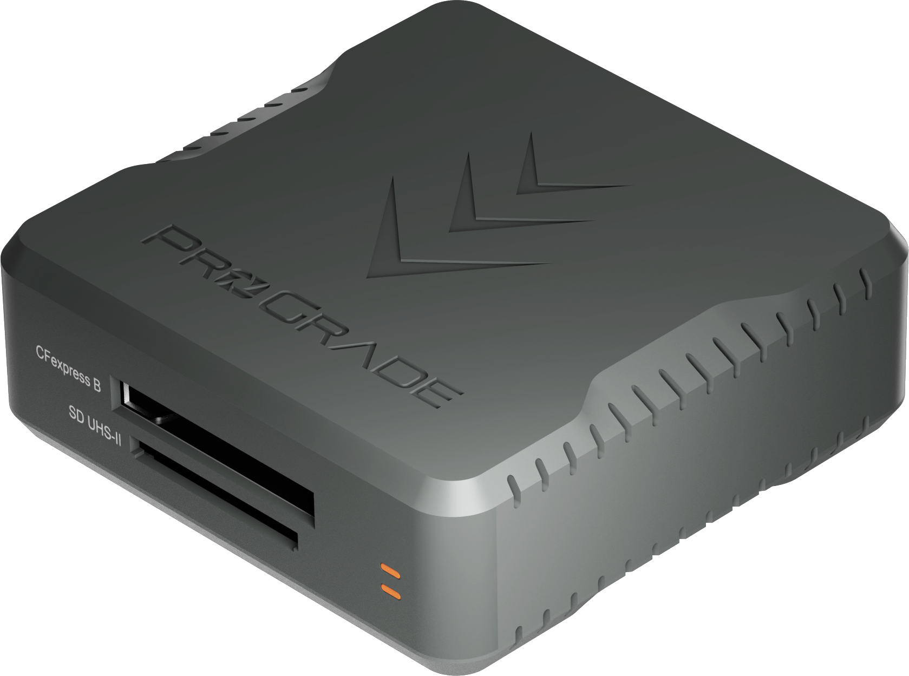
- Backward compatible with CFexpress 2.0 Type B cards
- Transfer rates of up to 40Gbps (5GBytes/sec)
- USB 4.0 interface – 2x faster than USB 3.2
- Patented magnetic base and included adhesive metal plate
- Integrated heat-sinks and active fan for enhanced cooling performance
- Refresh Pro™ enabled*
- USB 4.0 certified cable included
- MSRP $149.99

ProGrade Digital CFexpress Type A / SDXC UHS-II Dual-Slot USB 4.0 Card Reader Key Features:

- Dual-slot card reader for CFexpress 4.0 Type A and SDXC-UHS-II cards
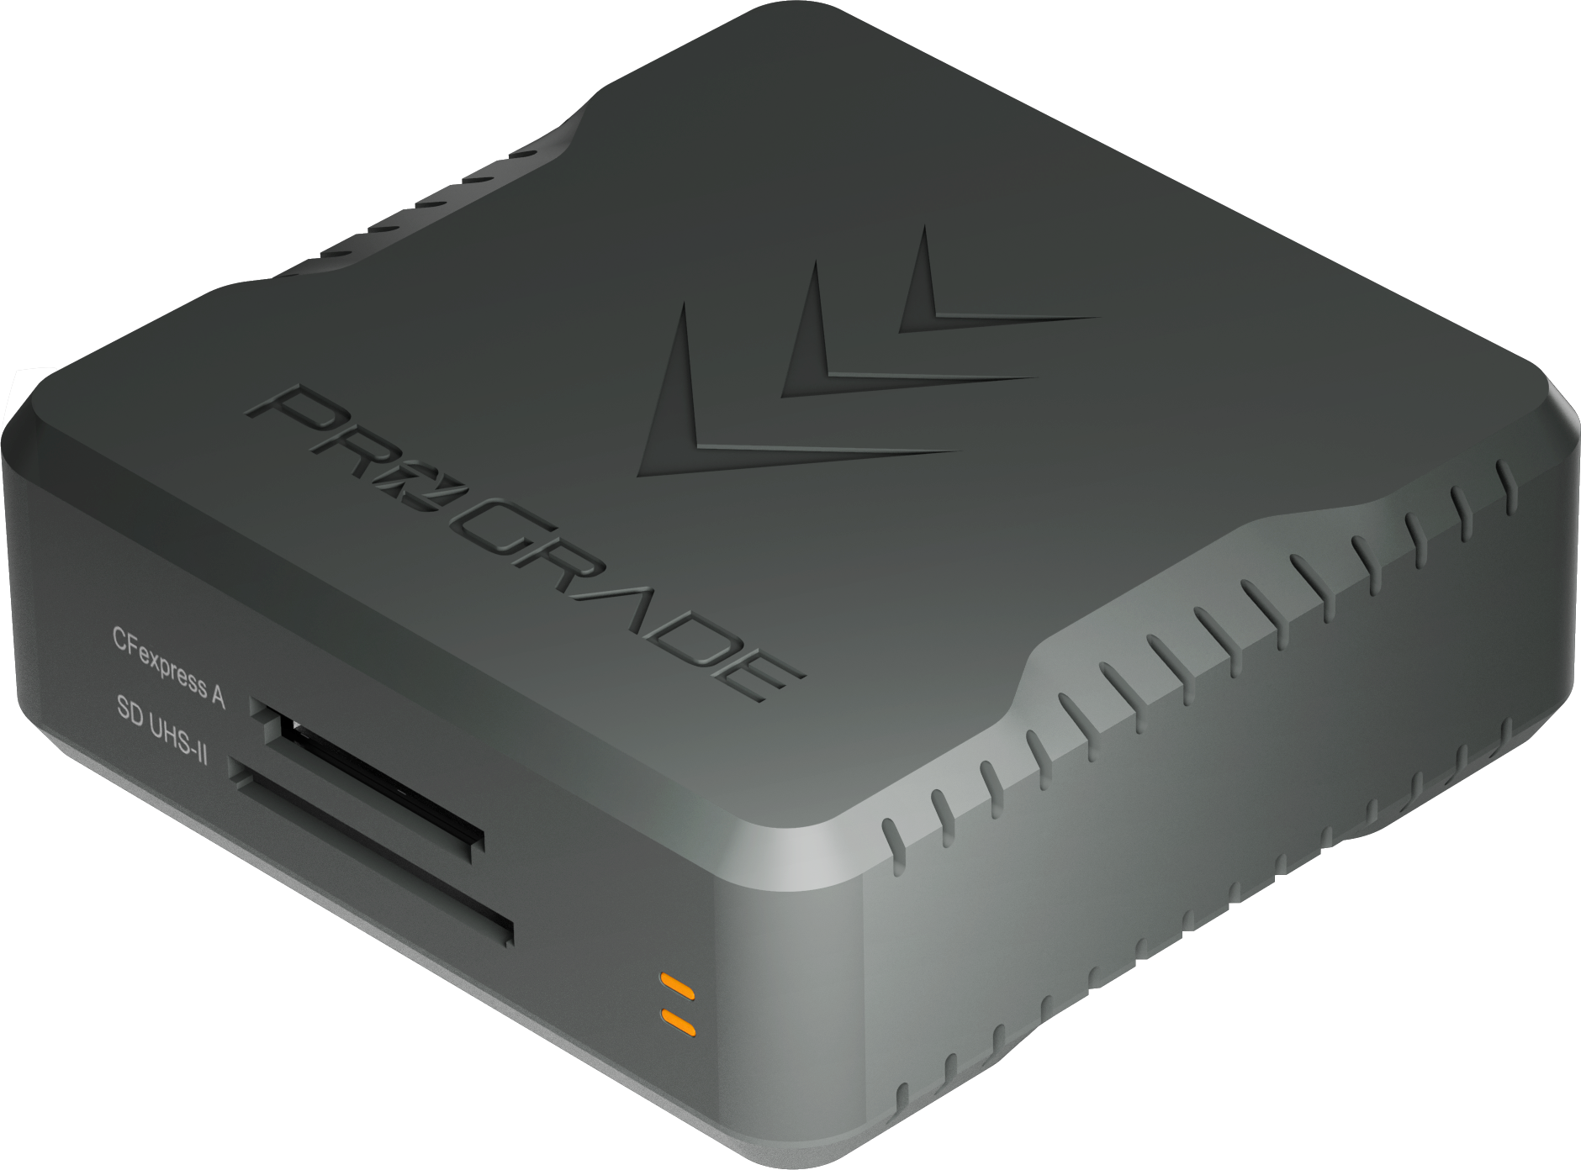
- Backward compatible with CFexpress 2.0 Type A cards
- Transfer rates of up to 40Gbps (5GBytes/sec)
- USB 4.0 interface – 2x faster than USB 3.2
- Patented magnetic base and included adhesive metal plate
- Integrated heat-sink and active fan for enhanced cooling performance
- Refresh Pro™ enabled*
- USB 4.0 certified cable included
- MSRP $149.99

Like all ProGrade products, each reader contains a unique serial number to ensure best-in-class after-sales support and tight quality control of the components used inside. Using this serial number, a customer can register their product at http://progradedigital.com/register.

Customers may purchase ProGrade Digital products on https://progradedigital.com/, B&H Photo and Video, or Adorama websites along with many other retailers around the globe. Customers in select regions may purchase on Amazon with Prime shipping.

About ProGrade Digital, Inc.
ProGrade Digital focuses exclusively on the design and marketing of digital memory cards, card readers, and workflow software required by imaging professionals. Flagship products include ProGrade Digital CFexpress™ and ProGrade Digital SDXC UHS-II V90 memory cards offered in a range of capacities and USB 3.2 Gen 2, and USB 4.0 high-speed readers. ProGrade Digital memory cards and workflow solutions are available for purchase globally through Amazon.com, on the company website, and also B&H Photo and Video.

*Refresh Pro™ functionality requires ProGrade Digital Refresh Pro™ software application and a ProGrade Digital card and reader. This is a great way to monitor card health and restore the card back to factory-fresh conditions. Each reader includes a USB-C Refresh Pro adapter, enabling Mac users to access the full functionality of Refresh Pro.

High-resolution product photos and logo for download: 2026-04-17 PG05.7 and PG09.7 Dual-Slot USB 4.0 Readers

ProGrade Digital is an authorized licensee of SDXC, CFast 2.0,4.0, and CFexpress trademarks. All other brand or product names in the release are trademarks or registered trademarks of their respective holders.

Media Contact:
David Saucedo
Director of Marketing
ProGrade Digital, Inc.
dsaucedo@progradedigital.com
831.737.9561

