PROGRADE DIGITAL™ ANNOUNCES A THUNDERBOLT 3™ CFEXPRESS™ AND XQD READER AND A DUAL-SLOT CFEXPRESS AND SDXC™ READER
Data transfer rate capability up to 5GB/s revolutionizes workflow for imaging professionals
San Jose, CA - March 19, 2020, 8:00 am —ProGrade Digital™, founded with a mission to provide the highest quality professional grade digital memory cards and workflow solutions, announces two new card readers to its industry leading product line. The PG04 is a Thunderbolt 3 reader for CFexpress Type B and XQD cards that is capable of transferring data at speeds up to 40Gb/s (5GB/s). This enables you to take full advantage of the read speeds of your CFexpress cards to create a fast and efficient workflow. The PG05.5 is a replacement for the popular PG05 reader that has a USB 3.2 Gen 2 interface enabling simultaneous transfer of data from both card slots at up to 10Gb/s (1.25GB/s). The PG05.5 supports both CFexpress Type B and SDXC, UHS-II cards.

“These additions to our reader product line give our customers more choices for downloading content from the quickly emerging CFexpress Type B standard.” said Wes Brewer, founder and CEO of ProGrade Digital. “We are excited to introduce another pair of industry-leading card readers that provide greatly improved levels of performance to the workflow of creative professionals. Being able to download a 256GB card filled with data in less than 3 minutes represents a 3x to 5x improvement in speed compared current solutions in the market.”

The PG04 includes a certified Thunderbolt 3 cable while the PG05.5 includes both a USB 3.2 Gen2 type C to C and type C to A cables. Just like the rest of the ProGrade Digital reader line, these new readers have a patent-pending magnetic base and come with an adhesive metal plate to solidly attach the reader to any work surface – such as a laptop cover for greater convenience and functionality. “This feature is extremely popular with professionals who often find themselves editing in cramped spaces so we also included it in the larger PG04 reader.“ said Brewer.

ProGrade Digital CFexpress Type-B Readers:
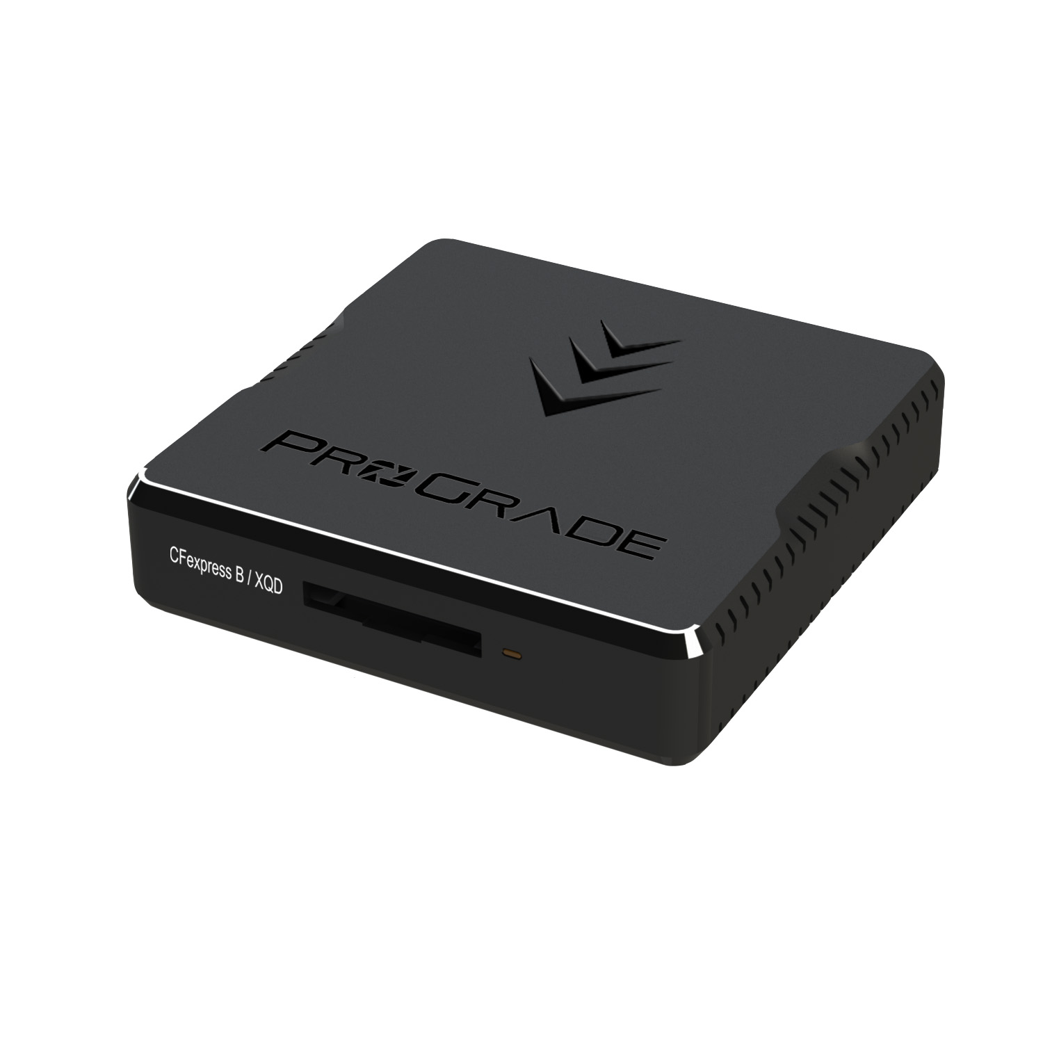
- PG04 Thunderbolt 3 Single-slot reader
  - Single-slot reader for CFexpress and XQD cards
  - Transfer rates up to 40Gb/s (5GB/s)
  - Thunderbolt 3 cable
  - Included adhesive metal plate
  - MSRP $129.99
- PG05.5 USB 3.2 Gen 2 Dual-slot reader
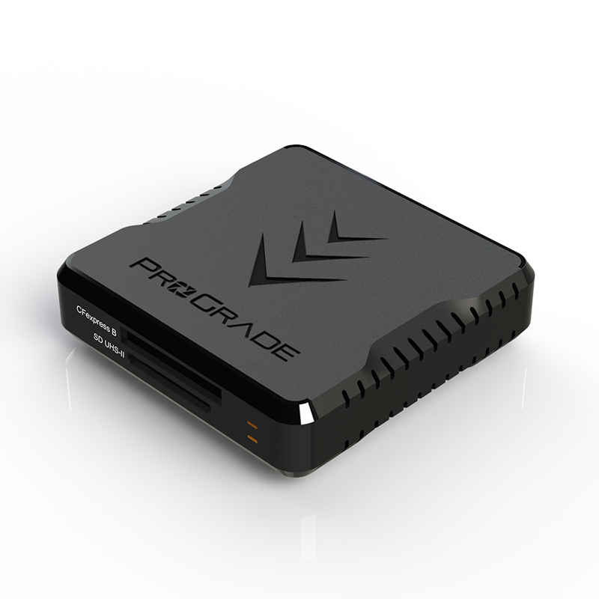
  - Dual-slot reader for CFexpress and SDXC UHS-II cards
  - This reader is not compatible with XQD cards
  - Transfer rates up to 10Gb/s (1.25GB/s)
  - USB type C to C and type C to A cables
  - Included adhesive metal plate
  - Refresh Pro ™ enabled*
  - MSRP $79.99
All ProGrade Digital readers have a printed serial number on the back of the readers. By referencing this number, a customer can register their serial number at https://progradeditigal.com/register to stay up to date on the latest technology developments.

The founders of ProGrade Digital are industry veterans in the removable storage and digital photography industries. Each, having spent time at leading companies such as Lexar and SanDisk, brings extensive expertise in the design, development and manufacture of digital storage products, plus longstanding relationships with key manufacturing and supply chain partners. The company focuses exclusively on development of memory cards, card readers and workflow software for professional imaging markets. Flagship products, ProGrade Digital CFast 2.0 and ProGrade Digital SDXC UHS-II, are optimized to render maximum performance when paired with high-end DSLR, mirrorless, camcorder and digital cinema cameras from manufacturers such as Canon, Nikon, Panasonic, Sony, Fuji, Olympus and Blackmagic. ProGrade Digital memory cards expand the creative visions of cinema and photography professionals around the world.

International customers may purchase ProGrade Digital products on the B&H Photo and Video website and Amazon in most countries, available with Prime Shipping. Customers may also purchase on www.progradedigital.com.

About ProGrade Digital, Inc.
ProGrade Digital focuses exclusively on the design and marketing of digital memory cards, card readers and workflow software required by imaging professionals. For more information, visit www.progradedigital.com
High resolution product photos and logo for download: http://bit.ly/ProGradeDigitalPRKit

*Refresh Pro functionality requires ProGrade Digital Refresh ProTM software application, ProGrade Digital card reader and a ProGrade Digital memory card with the Refresh Pro logo.

ProGrade Digital is an authorized licensee of SDXC, CFast 2.0 and CFexpress trademarks. All other brand or product names in the release are trademarks or registered trademarks of their respective holders.

Media Contact:
Mark Lewis
Vice President Marketing
ProGrade Digital, Inc.
mlewis@progradedigital.com
408.708.9292

###

